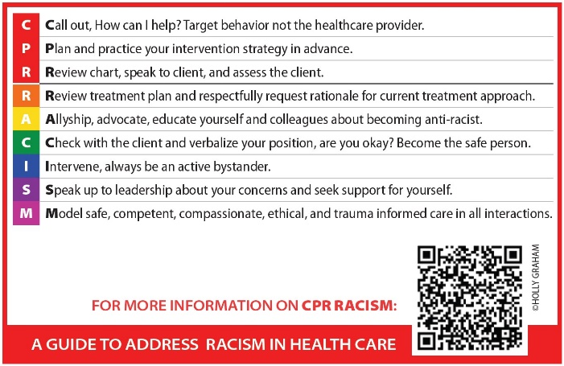
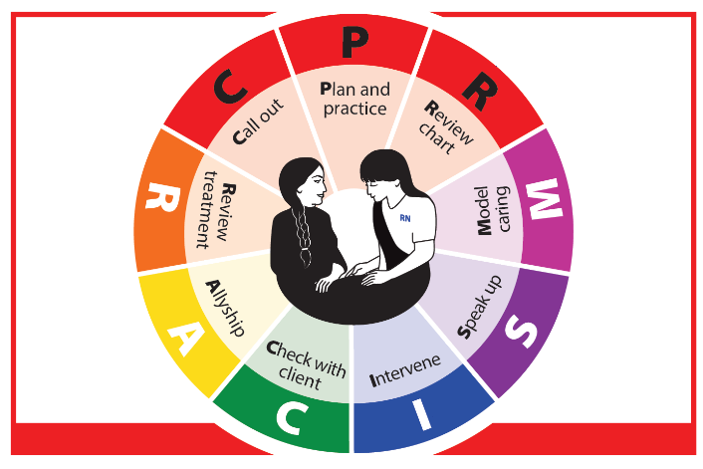
Evaluation: CPR RACISM Guide

Truth and Reconciliation Call to Action #24 is now required for accreditation in nursing schools in Canada. TRC Call #24 requires skill-based training, including anti-racist education and preparation. This concrete, practical, and visual guide was created to assist with teaching an intervention when racism or unsafe care is witnessed in health care. It creates and supports a “speak-up culture” and outlines an intervention. This guide is rooted in nursing values and ethical responsibilities outlined by CNA (2017) and the Standards of Practice required by the SRNA (2019).
The following survey is an evaluation of the tool. We would like to invite you to fill it out after using the guide. We will use this information to assess and improve the usefulness of the guide. The evaluation is anonymous. It should take less than 10 minutes to complete.
- Demographics
Age: ☐ 20-30 ☐ 31-40 ☐ 41-50 ☐ 51-60 ☐ 61-70 ☐ >71
Race/Ethnicity:

☐White
☐Indigenous/Métis/Inuit
☐Southeast Asian
☐South Asian
☐Middle Eastern
☐Latin

☐East Asian
☐Black
☐Multiracial
☐Other
☐Prefer not to say

Are you a student/learner?
☐ yes ☐ no
Please specify College or Department (nursing, pharmacy, medicine, etc.)

Years of professional practice
Please specify discipline (nursing, medicine, pharmacy, physical rehabilitation, etc.)

☐ 0-3 years
☐ 4-7 years
☐ 7-10 years
☐ 11-15 years
☐ 16-20 years
☐ 21-25 years
☐ 26-30 years
☐ 31-35 years
☐ 36-40 years
☐ 41 years plus

- Place of Employment (Health Care Environment)
☐ Acute Care: Hospital
☐ Community Health
☐ Teaching Institution
☐ Agency (please list)
☐ Other:
Geographical Location:
Town/City: _________________
Province: __________________
Country: ☐ Canada ☐ Other please specify
Setting:
☐ Urban
☐ Rural
☐ Northern and/or Isolated
Other:
Occupation:
Nurse
☐ LPN
☐ RN
☐ Psychiatric Nurse
☐ NP
Other:

- Current position
☐ Acute Care - Describe:
☐ Community/Public Health Nurse
☐ Clinical Instructor
☐ Instructor Post-Secondary Institution
☐Home Healthcare
☐Military Nurse
☐Faculty Post-Secondary Institution
☐Physician Office
Other (please specify)
- In what setting did you use the CPR RACISM tool? (check all that apply)
☐Teaching Institution (please specify)
Number of Learners/Participants
☐ Clinical Setting (please specify)
Number of Learners/Participants
☐ Other-please describe
Number of Learners/Participants
☐ I did not teach this in a formal setting but have been using it personally
- CPR RACISM Resources
  - CPR RACISM Publication: cpr-racism-article-hg.pdf
  - CPR RACISM Video: CPR RACISM - YouTube
  - CPR RACISM Card: CPR Racism postcard.indd

- Current Self- Assessment

1= very uncomfortable; 10 = very comfortable

- How comfortable were you before being exposed to CPR RACISM to intervene when you witnessed racism in health care? | 1☐ | 2☐ | 3☐ | 4☐ | 5☐ | 6☐ | 7☐ | 8☐ | 9☐ | 10☐
- How comfortable were you before being exposed to CPR RACISM to teaching others, including undergraduate students (nursing, medicine, pharmacy, etc.) to intervene when they witnessed racism in health care? | 1☐ | 2☐ | 3☐ | 4☐ | 5☐ | 6☐ | 7☐ | 8☐ | 9☐ | 10☐

- Please share the barriers or fears you have that interfere with your ability to intervene when you witness racism in healthcare.

- Evaluation of the CPR RACISM Guide

- What content was most helpful in the CPR RACISM guide?

- What type of support do you feel you need to implement the CPR RACISM guide?

1= very uncomfortable; 10 = very comfortable

- After reviewing the CPR RACISM resources (article, postcard, and the video) how comfortable are you to intervene now when you witness racism in health care? | 1☐ | 2☐ | 3☐ | 4☐ | 5☐ | 6☐ | 7☐ | 8☐ | 9☐ | 10☐
- How comfortable are you after reviewing the CPR RACISM resources to teaching others, including undergraduate students (nursing, medicine, pharmacy, etc.) to intervene when they witnessed racism in health care? | 1☐ | 2☐ | 3☐ | 4☐ | 5☐ | 6☐ | 7☐ | 8☐ | 9☐ | 10☐

- Please share any additional thoughts or suggestions you have regarding CPR RACISM guide.

These evaluations will be used to enhance the application and teaching of this CPR RACISM guide. Please email your evaluation to holly.graham@usask.ca.
Thank you for taking the time to help us evaluate this guide.

