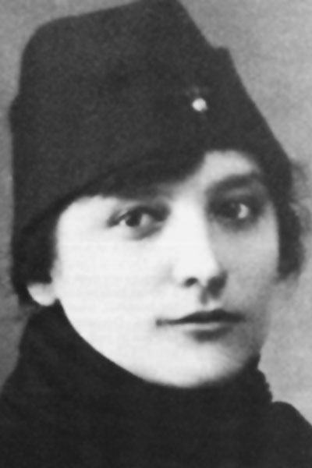
Edith Monture was born April 10, 1890 on the Six Nations of the Grand River near Brantford, Ontario. She was not able to attend nursing school in Canada, because many Canadian nursing schools excluded Indigenous woman at the time. In addition, the Indian Act was also a barrier to higher education for Indigenous people, because obtaining a degree or professional designation stripped an Indigenous person of their Indian Status for citizenship rights. In order to become a nurse, Edith had to obtain her nursing education from New York’s New Rochelle Nursing School, where she graduated first in her class.
Edith became the first Indigenous person in Canada to be recognized as registered nurse and served in World War 1. She became the first Indigenous woman to vote as a result of the Military Voters Act of 1917, which gave wartime nurses the right to vote. It’s important to note that Indigenous women as a whole could not legally vote in a Canadian federal election until 1960. In 1960, when all Indigenous Peoples gained the right to vote, her home served as a polling station helping to enfranchise Indigenous voters.
Edith Anderson Monture, 1890-1996 – courtesy Veterans Affairs Canada
After the war, Edith returned home to Six Nations of the Grand River, where she advocated for better Indigenous health care, working both as a nurse and midwife. In 1921, she married Claybran Monture; the couple went on to have five children.
Edith died in April 1996, just one week shy of her 106th birthday, and the same year the last Indian Hospital and Residential Schools officially closed in Canada. Her legacy left a significant impact both in her community and beyond.

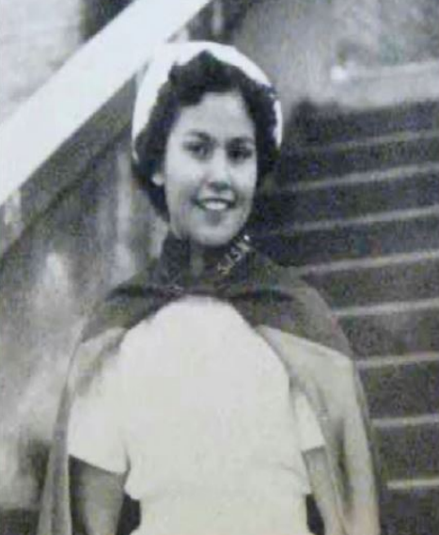
Rose Casper of the St'at'imc Nation was the first Indigenous nurse in Western Canada. She attended the Kamloops Indian Residential School and was among the first students to enter high school, graduating in 1952. In 1955, Rose graduated from the St. Josephs School of Nursing located in Victoria, BC. Rose worked in her home community of Shalalth as a nurse for over 50 years. To honour her legacy and service to her community, the Rose Casper Healing Centre was opened in Shalalth in 2003. The Centre remains a fixture in the community offering wellness services that are both traditional and contemporary. Rose retired in 2013.
Rose Casper

